Dealing with missing values
Step 1: Create a dataset with missing values
You can have the students manually create a dataset with some missing (NA) values:
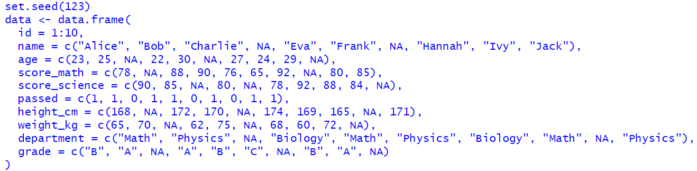

Step 2: Explore Different Methods to Deal with Null Values
1. Identifying Missing Values
You can ask students to identify which values are missing in the dataset:
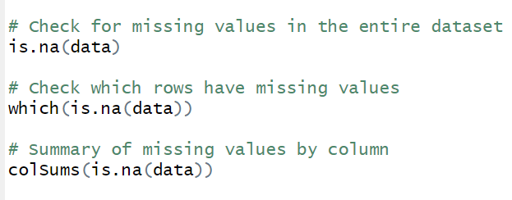
2. Removing Rows/Columns with Missing Values
One of the simplest methods is to remove rows or columns that contain a
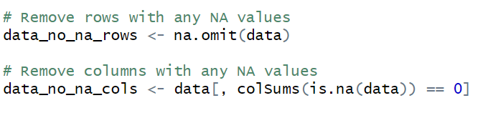
3. Filling Missing Values
You can explore different ways to fill in missing values based on the type of data:
- Filling with mean/median/mode (for numerical columns):
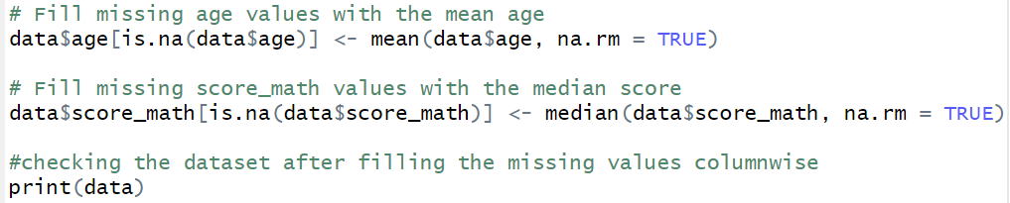
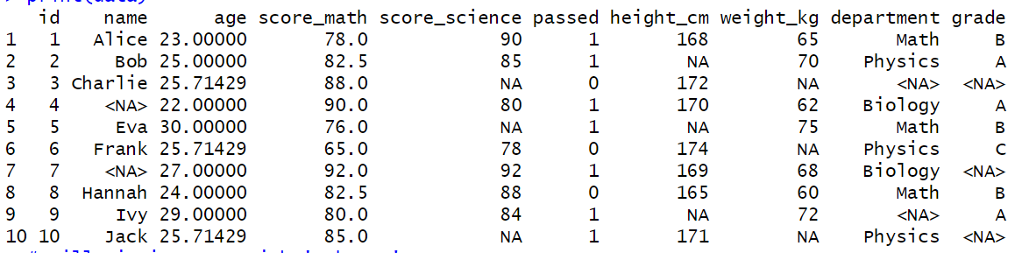
Filling with a constant (e.g., "Unknown" for categorical columns):
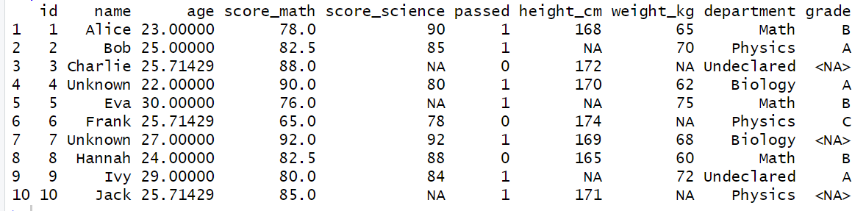

Fill the Null Values with 0
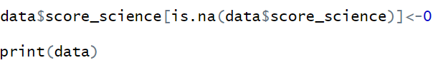
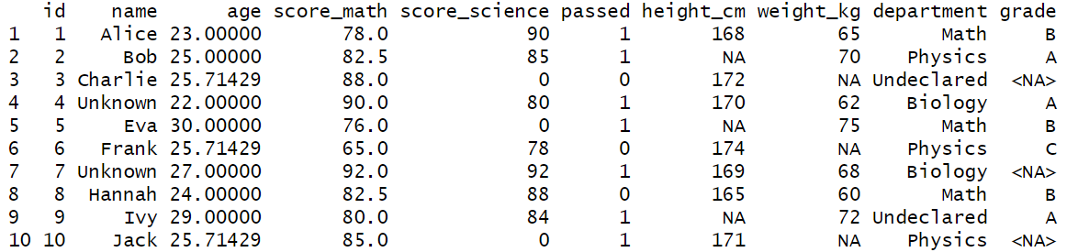
Conditional Imputation
Sometimes you can fill missing values based on some condition. For example, if a student's age is missing but they have a score, you can use an educated guess or other data to fill in the missing values.
